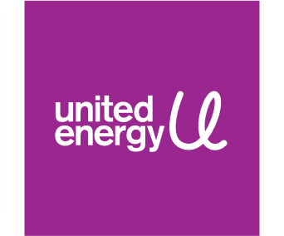

Position Description

6/04/2026 Maintenance Services Officer
Position title: | Maintenance Services Officer
Reports to: | Maintenance Manger

Business unit: | Service Delivery & Vegetation Management
Employment category: | Contract (Employment Agreement)

About United Energy
As an electricity distribution company we provide safe, reliable and affordable power to 700,000 Victorians in Melbourne's east and south eastern suburbs and the Mornington Peninsula using our network of poles, wires and infrastructure to bring power to homes and businesses across our service territory — that’s more than 13,000 kilometres of wires and 200,000 poles.
But we do so much more than manage poles and wires. We’re also the gateway to a clean energy future, dedicated to finding solutions and harnessing new technology to benefit our customers, communities and the environment. This includes industry leading projects in community batteries, demand management, smart charging for electric vehicles (EVs) and microgrids.
And as more customers choose solar, batteries, EVs and smart appliances — the electricity system is becoming increasingly complex, and so too is the level of innovation required to manage it. That’s where you come in.

About the Service Delivery & Vegetation Management team you’ll be part of
The Service Delivery & Vegetation Management team operates the network and delivers the capital and operational programs to deliver outstanding service across United Energy’s electricity distribution network. The team focus on ensuring the supply of safe, innovative, efficient and reliable electricity for customers. Services are delivered in the areas of 24/7 network operations, field delivery, design, engineering, vegetation management, resource management and customer projects.

Our core values
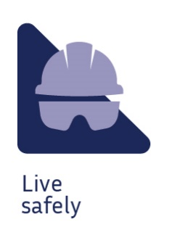 | 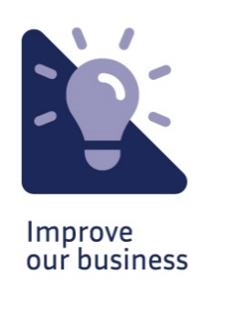 |  |  | 

Purpose of the position
This role is responsible to ensure the optimisation of maintenance issued as a result of asset inspection programs as well as miscellaneous reports from other sources.

Your key responsibilities

Optimise Maintenance Notifications
- Review, validate, scope and approve notifications raised through the cyclic inspection program in line with asset management policy and strategies
- Review and manage notifications from non-asset inspection reports
- Determine works to be issued in accordance with Electricity Network guidelines considering policy, asset performance, associated projects
- Identify and issue sites requiring specialist design to design group and resolve non specialist design technical issues
- Determine and manage opportunistic works or other programs to align with budgets

Scope and Issue Maintenance Works
- Optimise works for PM order
- Prepare material list and estimate for non-design sites where required
- Establish target date for sites if other than default policy date is appropriate
- Review, scope and issue/approve works from miscellaneous maintenance reporting
- Work issue other business initiated maintenance programs
Audit Quality and Compliance
- Undertake audits of the maintenance process to ensure compliance to policy, procedures and data integrity
Stakeholder Management
- Interface with Design and Electricity Networks on policy interpretation, direction, development and feedback
- Provide advice and promote asset maintenance activities to internal and external business units

What you’ll bring to the business

Education / Qualifications:
- Diploma of ESI – Power Systems

Knowledge:
- The position needs a detailed knowledge of the electricity distribution networks including basic design, construction and operation of lines assets
- Awareness of Reliability Centred Maintenance and asset condition assessment techniques
- Sound knowledge of Maintenance policies and procedures as well as Asset Inspection policies and processes
- Awareness of safety and environmental regulations
- SAP and other project/program management, estimating or management tools are required

Experience:
- Prior experience as a technical/design officer, line worker, substations or asset inspector is desirable
- Demonstrated experience with substations assets, underground cable assets and overhead distribution assets

The skills and competencies you’ll have

‘Thought’ competencies
- Decision Quality: Considers various points and uses good judgement to make decisions and recommendations, knowing when to act or escalate
- Balances stakeholders: Anticipating and balancing the needs of multiple stakeholders
- Customer focus: Building strong customer relationships and delivering customer-centric solutions

‘Result’ competencies
- Action oriented: Taking on new opportunities and tough challenges with a sense of urgency, high energy, and enthusiasm
- Plans and aligns: Planning and prioritising work to meet commitments aligned with organisational goals
- Directs work: Providing direction, delegating, and removing obstacles to get work done

‘People’ competencies
- Collaborates: Building partnerships and working collaboratively with others to meet shared objectives
- Communicates effectively: Developing and delivering multi-mode communications that convey a clear understanding of the unique needs of different audiences
- Builds networks: Effectively building formal and informal relationship networks inside and outside the organisation

‘Self’ competencies
- Demonstrates self-awareness: Using a combination of feedback and reflection to gain productive insight into personal strengths and weaknesses
- Situational adaptability: Adapting approach and demeanour in real time to match the shifting demands of different situations
- Being resilient: Rebounding from setbacks and adversity when facing difficult situations

Other relevant information
- Travel to other work locations / sites may be required

