

Position Description

17/08/2026 Team Leader Urban Underground Distribution
Position title: | Team Leader Urban Underground Distribution
Reports to: | Manager Urban Programs

Business unit: | Network Services
Employment category: | Contract (Employment Agreement) / Enterprise Agreement (PP20-24)

About CitiPower and Powercor
As electricity distribution companies we provide safe, reliable and affordable power to 1.3 million Victorian customers. We use our network of poles, wires and infrastructure to bring power to homes and businesses across almost 65% of Victoria — that’s more than 120,000 kilometres of wires and 850,000 poles.
But we do so much more than manage poles and wires. We’re also the gateway to a clean energy future, dedicated to finding solutions and harnessing new technology to benefit our customers, communities and the environment. This includes industry leading projects in community batteries, demand management, smart charging for electric vehicles (EVs) and microgrids.
And as more customers choose solar, batteries, EVs and smart appliances — the electricity system is becoming increasingly complex, and so too is the level of innovation required to manage it.

About the Network Services team you’ll be part of
Network Services is a 24x7 operation, constructing and maintaining electrical infrastructure and responding to faults and emergencies throughout the CitiPower and Powercor electricity distribution networks. The team is responsible for design, project management, workforce management, field construction and supply chain and logistics management. Functional teams include network control and operations, major projects, maintenance, field services, design and customer programs and works delivery management.

Our core values
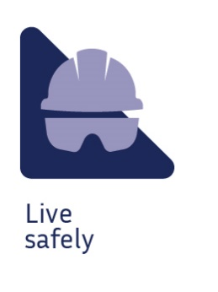 | 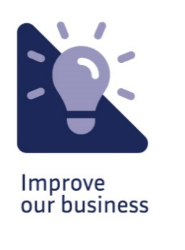 |  |  | 

Purpose of the position
This role is responsible as the frontline leader, for the provision of high quality and cost effective Program Delivery and Design services to support the delivery projects for internal and external clients.
This position is responsible for the delivery of high quality and efficient project coordination and through the initiate phase of projects, to meet the Network Services and Electricity Networks works program.

Your key responsibilities

Team Leadership
- Enable and encourage others to participate in decision making whilst considering broader business agenda and objectives
- Contribute to and implement plans that ensure overall capabilities of the team to enable delivery of assigned project activities/services as required
- Contribute to and implement plans that build team morale, employee engagement and generate commitment to and understanding of company vision and strategy
- Contribute to and implement plans that result in a positive commercial and customer centric culture

Innovation and Continuous Improvement
- Develop and implement new and innovative ways to meet business needs by applying technical expertise and experience
- Learn from project/activities and apply learnings to future projects
- Provide input into the development of asset management strategies, standards and work practices as required

Contractor Management
- Manage external contractors providing delivery and design services to ensure cost effective, timely and high quality services

Functional and Technical
- Deliver the Electricity Networks program of major projects and customer works
- Implement and continuously improve design and project delivery practices
- Work collaboratively with the customer service group for the delivery of design and project delivery services.
- Deliver on time and on budget for all associated project and program responsibilities
- Derive value from projects in the initiation phase, delivering optimal asset outcomes for the overall business
- Oversee the scoping, planning and delivery of the program of works

Continuous Improvement and Best Practices
- Successfully develop and embed fit for purpose capabilities, processes or process improvements that meet the agility needed for the business to be competitive
- Contribute to a culture that is focused on workplace continuous improvement through identifying and supporting improvement initiatives and opportunities
- Actively support and embed new or modified processes and systems

What you’ll bring to the business

Education / Qualifications:
- Tertiary qualification in an Engineering, Technical or Management discipline

Knowledge:
- Detailed knowledge of all aspects associated with project management
- Detailed knowledge of the electrical distribution network, particularly design and compliance with relevant customer and Australian Standards
- Working knowledge of the Customer Initiated Augmentation Works, Electricity Supply Policy and associated codes
- Strong interpersonal skills, including the ability to work across the organization and interact / influence / negotiate effectively at all levels of management and with peers
- Proven ability in business communications to manage and align expectations of staff, customers and internal stakeholders
- Knowledge and understanding of regulatory compliance issues, Occupational Health Safety Act and overhead line standards and codes
- Strong understanding of best practice in innovation and value improvement

Experience:
- Substantial experience in the power industry in the areas of design and / or construction / operations
- Experience leading a large and diverse technical workforce

The skills and competencies you’ll have

‘Thought’ competencies
- Strategic mindset: Seeing ahead to future possibilities and translating them into breakthrough strategies
- Balances stakeholders: Anticipating and balancing the needs of multiple stakeholders
- Manages complexity: Making sense of complex, high quantity, and sometimes contradictory information to effectively solve problems

‘Result’ competencies
- Directs work: Providing direction, delegating, and removing obstacles to get work done
- Ensures accountability: Holding self and others accountable to meet commitments
- Plans and aligns: Planning and prioritising work to meet commitments aligned with organisational goals

‘People’ competencies
- Builds effective teams: Building strong-identity teams that apply their diverse skills and perspectives to achieve common goals
- Develops talent: Developing people to meet both their career goals and the organisation’s goals
- Drives vision and purpose: Painting a compelling picture of the vision and strategy that motivates others to action

‘Self’ competencies
- Being resilient: Rebounding from setbacks and adversity when facing difficult situations
- Courage: Stepping up to address difficult issues, saying what needs to be said
- Situational adaptability: Adapting approach and demeanour in real time to match the shifting demands of different situations

‘Leadership’ competencies
- Manage self: Willing and able to assess and apply own skills, abilities and experience. Being aware of own behaviour and how it impacts on others.
- Take the lead: Taking the lead and pushing for performance. Take charge, declaring, decisive. Push, hold people accountable.
- Enable others: Creates conditions for others to lead and contribute. Empowers others. Listens, open to influence. Supports, treats people well.
- Strategic focus: Position your team for the future. Set direction, drive improvements and growth, embrace innovation.
- Execution and results: Position your team for the future. Set direction, drive improvements and growth.

Other relevant information
- Availability duty will be required
- Travel to other work locations / sites may be required
- Direct reports - FTE direct reports: 20 Contractor direct reports: 0

