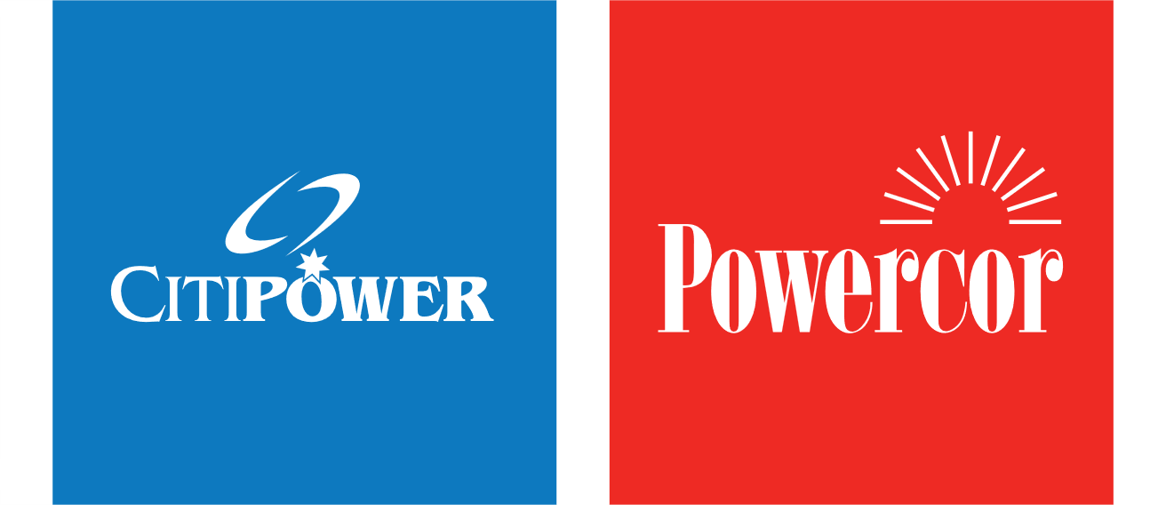

Position Description

6/08/2026 Environment and Sustainability Program Specialist
Position title: | Environment and Sustainability Program Specialist
Reports to: | Environment and Sustainability Manager

Business unit: | People, Culture & Legal
Employment category: | Contract (Employment Agreement)

About CitiPower and Powercor
As electricity distribution companies we provide safe, reliable and affordable power to 1.3 million Victorian customers. We use our network of poles, wires and infrastructure to bring power to homes and businesses across almost 65% of Victoria — that’s more than 120,000 kilometres of wires and 850,000 poles.
But we do so much more than manage poles and wires. We’re also the gateway to a clean energy future, dedicated to finding solutions and harnessing new technology to benefit our customers, communities and the environment. This includes industry leading projects in community batteries, demand management, smart charging for electric vehicles (EVs) and microgrids.
And as more customers choose solar, batteries, EVs and smart appliances — the electricity system is becoming increasingly complex, and so too is the level of innovation required to manage it.

About the People, Culture & Legal team you’ll be part of
People, Culture & Legal support the wider business by providing practical, value-add advice and services to the business, supporting the achievement of our strategic objectives, and ensuring that the business is embracing and living our organisational values. Key responsibilities lay in areas of health, safety and sustainability, human resources, organisational capability development, remuneration and benefits, company secretary, First Peoples and legal services.

Our core values
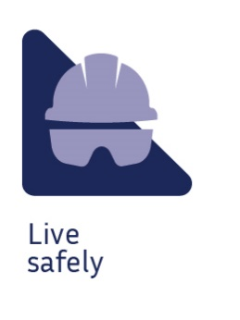 | 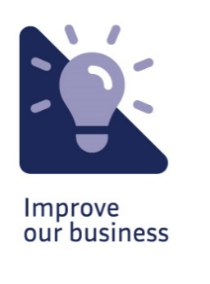 |  |  | 

Purpose of the position
Be a subject matter expert in environmental and sustainability by coordinating the delivery of key environmental risk, compliance and climate-related programs across the organisation.
Through effective stakeholder engagement and technical expertise, the role supports the implementation and continuous improvement of environmental and sustainability initiatives that contribute to regulatory compliance, risk reduction and organisational sustainability objectives.
The role provides specialist advice on designated environmental and climate-related matters and works collaboratively with internal and external stakeholders to support informed decision-making and continuous improvement.

Your key responsibilities

Program Delivery and Technical Expertise
- Lead the delivery and continuous improvement of assigned environment and sustainability programs across the business.
- Provide specialist expertise in environmental and sustainability areas including land contamination, asbestos management, PCB management, environmental risk management and climate reporting.
- Contribute to the development and maintenance of standards, procedures, guidance material and assurance frameworks that support compliance and continuous improvement.
- Monitor legislative changes, industry developments and emerging practices, identifying opportunities to improve environmental and sustainability performance.

Environmental Programs
- Coordinate implementation of the environmental capital program, supporting compliance, risk management and project delivery outcomes.
- Lead the ongoing development of the Land Contamination Management Program, including risk assessment, remediation oversight and due diligence activities.
- Review and update environmental procedures and processes to support compliance obligations and risk reduction initiatives.
- Manage relationships with specialist consultants and technical service providers supporting environmental program delivery.

Environmental Risk and Assurance Management
- Maintain environmental risk registers to meet ISO 14001 requirements and support business units in implementing effective controls and mitigation measures.
- Analyse environmental performance data and recommend opportunities to improve outcomes and reduce risk.
- Coordinate environmental assurance activities, including Division 6 Asbestos Audit programs and corrective action management.

Climate Reporting and Emissions Management
- Provide technical input into climate risk assessments, scenario analysis and climate-related business planning activities.
- Support the delivery of mandatory and voluntary climate-related reporting obligations, including Australian Sustainability Reporting Standards (ASRS) requirements.
- Contribute to the development and maintenance of organisational carbon emissions models and associated methodologies.
- Support the development and monitoring of emissions reduction targets, performance indicators and related initiatives.
- Work with stakeholders to document, analyse and track greenhouse gas emission reduction activities.

Stakeholder Engagement and Capability Building
- Develop and maintain effective working relationships with operational teams, project managers, corporate functions, regulators and service providers.
- Liaise with regulators and government agencies on environmental matters, supporting regulatory reporting, compliance activities and the resolution of environmental issues.
- Develop and deliver environmental and climate-related awareness, education and guidance materials.
- Translate technical requirements into practical and actionable advice for stakeholders.
- Contribute environmental and sustainability expertise to governance forums, working groups and business improvement initiatives.

What you’ll bring to the business

Education / Qualifications:
- Bachelor’s degree in environmental science, environmental management, sustainability, engineering or a related discipline.
- Relevant postgraduate qualification in environmental management, sustainability or a related field (desirable).

Knowledge:
- Knowledge of environmental legislation, regulations, standards and environmental management systems.
- Understanding of environmental risk management, assurance processes and environmental compliance requirements.
- Knowledge of climate-related reporting, greenhouse gas emissions management and emissions reduction initiatives.
- Strong stakeholder engagement and communication skills, with the ability to provide practical environmental advice across the business.
- Well-developed analytical and problem-solving skills, with the ability to assess issues, identify risks and support continuous improvement.

Experience:
- Extensive experience in environmental and/or sustainability roles within utilities, infrastructure, construction, resources or a related industry.
- Experience supporting environmental compliance, risk management and environmental improvement initiatives, such as land contamination, asbestos management, environmental assurance or environmental risk management.
- Experience supporting climate-related reporting, greenhouse gas accounting and emissions reduction initiatives.
- Experience engaging with external stakeholders and regulators on environmental matters.
- Strong written and verbal communication skills, including the preparation of reports, procedures and technical advice.
- Experience managing consultants and consultants (preferable).

The skills and competencies you’ll have

‘Thought’ competencies
- Manages complexity: Making sense of complex, high quantity, and sometimes contradictory information to effectively solve problems
- Balances stakeholders: Anticipating and balancing the needs of multiple stakeholders
- Decision Quality: Considers various points and uses good judgement to make decisions and recommendations, knowing when to act or escalate

‘Result’ competencies
- Action oriented: Taking on new opportunities and tough challenges with a sense of urgency, high energy, and enthusiasm
- Ensures accountability: Holding self and others accountable to meet commitments
- Optimises work processes: Knowing the most effective and efficient processes to get things done, with a focus on continuous improvement

‘People’ competencies
- Communicates effectively: Developing and delivering multi-mode communications that convey a clear understanding of the unique needs of different audiences
- Collaborates: Building partnerships and working collaboratively with others to meet shared objectives
- Organisational savvy: Manoeuvring comfortably through complex policy, process, and people-related organisational dynamics

‘Self’ competencies
- Demonstrates self-awareness: Using a combination of feedback and reflection to gain productive insight into personal strengths and weaknesses
- Being resilient: Rebounding from setbacks and adversity when facing difficult situations
- Situational adaptability: Adapting approach and demeanour in real time to match the shifting demands of different situations

Other relevant information
- Availability duty will be required
- Travel to other work locations / sites may be required
- Drivers licence required

